Robinhood 10-K, Financial Statements, and Financial Ratios:
- Robinhood’s 2025 10-K Annual Report can be found HERE
- Attached are financial statement screenshots from that report
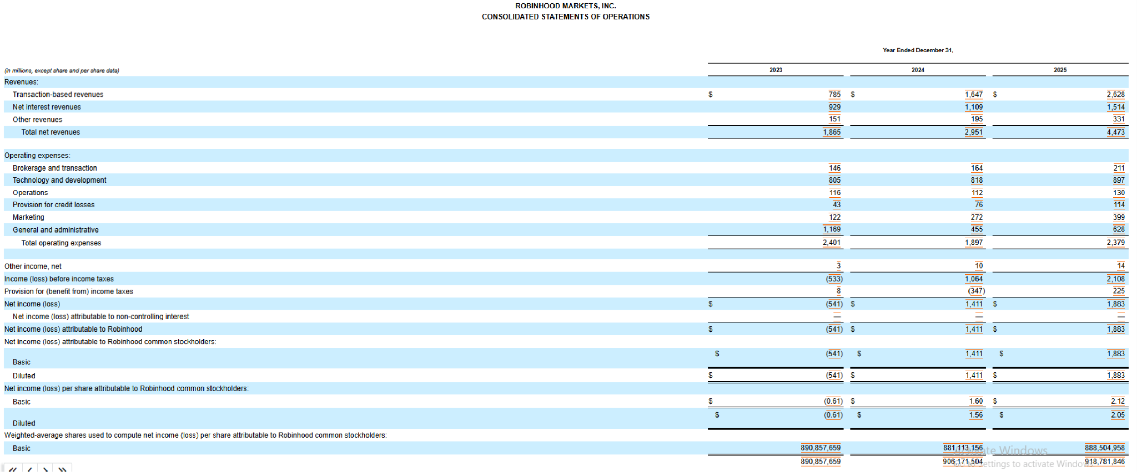
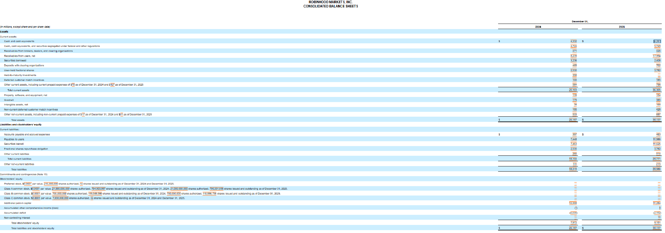
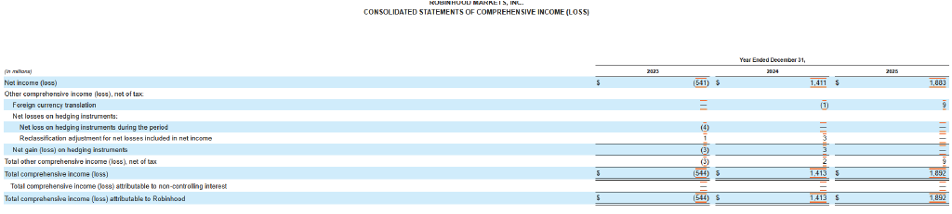
- Current ratio (CA / CL)
  - 36,305 / 28,771 = 1.26
- Debt Ratio (TL / TA)
  - 28,986 / 38,137 = 0.76 or 76%
- Equity Multiplier (TA/TE or TA/Net Worth)
  - 38,137 / 9,151 = 4.17
- Total-Asset-Turn-Over (Sales / Total Assets)
  - 4,473 / 38,137 = 0.117x
- Pre-tax Profit Margin (EBT / Sales)
  - 2,108 / 4,473 = 47.13%
- Pre-tax Return-On-Assets (EBT / TA)
  - 2,108 / 38,137 = 5.53%
- Pre-tax Return-On-Equity (EBT / TE)
  - 2,108 / 9,151 = 23.04%

Industry Classification & Benchmarks:
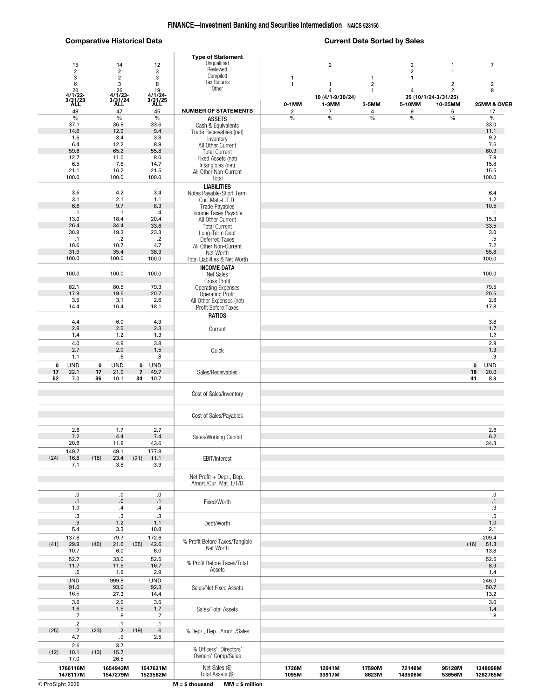
Robinhood Markets, Inc. is classified by the SEC under SIC 6211 (Security Brokers, Dealers & Flotation Companies). For benchmarking purposes, this analysis uses RMA's NAICS 523150 (Investment Banking and Securities Intermediation) industry table. This analysis refers to the values shown in the 4/1/24 - 3/31/25 ALL column.
- Current ratio
  - 2.3
- Debt Ratio (RMA calls equity ‘worth’)
  - 1 - 0.38.3 = 0.617 or 61.7%
- Equity Multiplier (TA/TE or TA/Net Worth)
  - 100 / 38.3 = 2.61
- Total-Asset-Turn-Over
  - 1.7
- Pre-tax Profit Margin (using earnings before taxes, EBT, rather than net income)
  - 18.1%
- Pre-tax Return-On-Assets
  - 16.7%
- Pre-tax Return-On-Equity
  - 42.6%

Comparative Analysis

Metric | Robinhood | RMA Benchmark | Difference | Assesment
Current Ratio | 1.26 | 2.3 | -1.04 | Below Benchmark
Debt Ratio | 0.76 | 0.61 | 0.15 | Higher Leverage
Equity Multiplier | 4.17 | 2.61 | 1.56 | Higher Leverage
Total Asset Turnover | 0.117 | 1.7 | -1.583 | Below Benchmark
Pre-tax Profit Margin | 47.13% | 18.1% | 29.03% | Strong
Pre-tax ROA | 5.53% | 16.7% | -11.17% | Below Benchmark
Pre-tax ROE | 23.04% | 42.6% | -19.56% | Below Benchmark

Interpretations
- Liquidity
  - Robinhood’s liquidity metrics are lower than the industry benchmark (1.26 current ratio compared to 2.3 industry benchmark). However, a current ratio of 1.26 still indicates that Robinhood’s current assets exceed current liabilities, meaning the company can cover its short-term obligations.
- Efficiency in the use of assets
  - Robinhood is less efficient in using its assets compared to the industry benchmark. A total asset turnover of 0.117 indicates that Robinhood generates about $0.12 in sales for every $1.00 of total assets, while the industry benchmark of 1.7 indicates similar companies generate $1.70 in sales for every $1.00 of assets.
- Degree of financial leverage
  - Robinhood’s debt ratio of 0.76 shows that a larger portion of their assets are financed through liabilities compared to the industry benchmark of 0.61. Robinhood’s equity multiplier supports this with a value of 4.17 compared to the industry benchmark of 2.6, which further shows a greater reliance on liabilities to finance its assets.
- How well all expenses are being contained
  - Robinhood’s pre-tax profit margin of 47.13% is significantly higher than the industry benchmark of 18.1%, which demonstrates the effectiveness at which Robinhood handles expenses. Robinhood's pre-tax profit margin of 47.13% shows nearly half of its revenue remains as pre-tax earnings after the expenses reflected in EBT.
- Overall profitability
  - Robinhood’s pre-tax ROA of 5.53% demonstrates that Robinhood is less efficient at generating earnings from its assets compared to the industry benchmark of 16.7%. Similarly, Robinhood’s pre-tax ROE of 23.04% is short of the 42.6% industry benchmark, meaning Robinhood is generating weaker returns on equity.

Executive Summary
Robinhood shows strong pre-tax profit margins relative to the industry benchmark but weaker liquidity, asset efficiency, and returns on assets and equity relative to the industry benchmark. Its 47.13% pre-tax profit margin substantially exceeds the 18.1% benchmark, while its 5.53% pre-tax ROA and 23.04% pre-tax ROE are below the industry benchmark. Robinhood also exhibits greater financial leverage, with a 76% debt ratio compared with the 61% industry benchmark. Overall, the analysis suggests that profitability is a strength, while asset utilization, capital structure, and returns generated from the company's asset and equity base represent areas for further evaluation.

Key Takeaways
Strengths
- Pre-tax profit margin substantially exceeds the industry benchmark.
- Current assets exceed current liabilities.
Areas of Concern
- Liquidity is below the industry benchmark.
- Leverage is substantially higher than the benchmark.
- Asset turnover and ROA are considerably below benchmarks.
- ROE is below the industry benchmark despite relatively high leverage

Recommendations
- Given the stark difference in total asset turnover values between Robinhood and the industry benchmark (0.117 and 1.7 respectively), Robinhood could improve asset efficiency by increasing revenue generated from its existing asset base or by improving the productivity of its assets.
- For Robinhood to move closer towards the debt ratio benchmark (reducing their leverage), the company would need to reduce liabilities or increase assets relative to debt) (Robinhood at 0.76 debt ratio compared to industry benchmark of 0.61)
- For Robinhood to improve pre-tax ROA and pre-tax ROE (5.53% and 23.04%) compared to the industry benchmark (16.7% and 42.6%), the company would need to increase earnings or use its assets and equity more efficiently to generate higher returns.

